**Online on Interpolation**

Dissolved oxygen (DO) is the amount of oxygen that is present in water. Dissolved oxygen is one of the most important parameters in aquatic systems. Dissolved oxygen is necessary to many forms of life including fish, invertebrates, bacteria and plants. The actual amount of dissolved oxygen varies depending on temperature, pressure and salinity. In this problem we will explore the effects of temperature and pressure on oxygen solubility in freshwater.

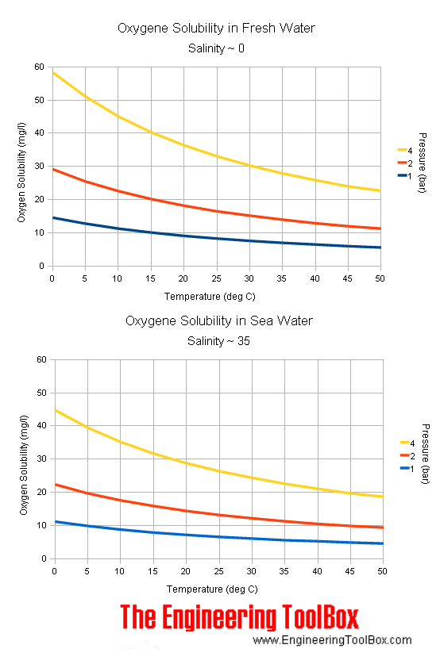

You are given a text file *dissolvedO2.csv* file which contains the concentration of dissolved oxygen for different temperatures at two different pressure levels in freshwater (i.e., salinity ~ 0 ppm). Thus, there are three columns in the file. The first column represents the temperature in Celsius. The next two columns contain, corresponding to each temperature value, the oxygen concentration (in mg/L) in fresh freshwater for the pressure values- 1 bar and 2 bar, respectively.

Now you have to perform the following tasks.

* Read the file from your program to store the values in an array. You must use numpy arrays.
* Then take a temperature, *T* as input from the user (the value will be within the range of temperatures in the file *dissolvedO2.csv*). Now you need to find, for each of the pressure values, the oxygen solubility, *o* (in mg/L) for the temperature, *T* using **fourth-order (quartic) Newton’s interpolating polynomial**.
* Also, find the absolute approximate relative error for the quartic polynomial for each of the two pressure values.
* Finally, plot a line graph of oxygen solubility against temperature for each of the given pressure values and indicate the interpolated values in respective graphs.